Tehama Wildlife Area
Vegetation and Fuels Management Plan

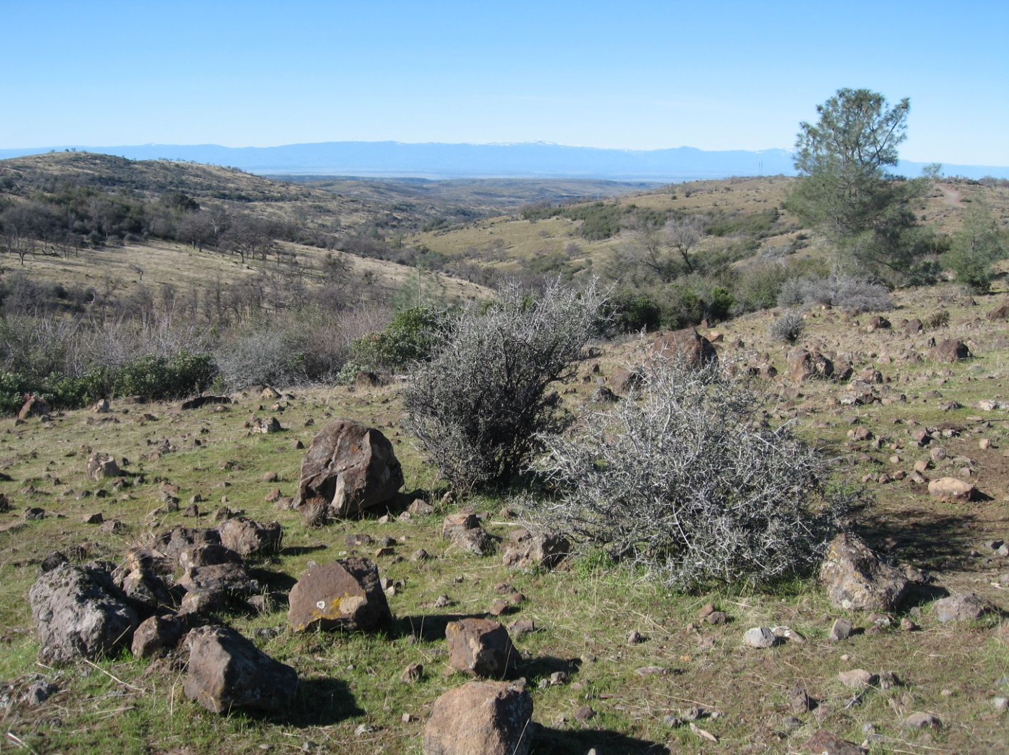

Prepared by
Tehama County Resource Conservation District
2 Sutter Street, Suite D
Red Bluff, CA 96080

In Cooperation with the California Department of Fish and Game
Tehama Wildlife Area
P.O. Box 188
Paynes Creek, CA 96075

TABLE OF CONTENTS

I. PURPOSE AND NEED FOR THIS PLAN 1
II. PLANNING AREA DESCRIPTION 2
III. FIRE HISTORY AND FIRE REGIMES 5
IV. CURRENT VEGETATION AND FUELS MANAGEMENT WITHIN THE PLANNING AREA 6
V. DEVELOPMENT OF A FUELS MANAGEMENT PROGRAM WITHIN THE TEHAMA WILDLIFE AREA 6
VI. TEHAMA WILDLIFE AREA PROGRAM GOALS 8
VII. RECOMMENDED GENERAL IMPLEMENTATION MEASURES 9
VIII. RESEARCH AND MONITORING PRIORITIES 11

Map A 13

BIBLIOGRAPHY 14

TEHAMA WILDLIFE AREA
VEGETATION AND FUELS MANAGEMENT PLAN

PURPOSE AND NEED FOR THIS PLAN

Scope of Plan. During the winter of 2010, the Tehama County Resource Conservation District (TCRCD) entered into an agreement with the California Department of Fish and Game (DFG) in order to manage Agricultural Lease Plans(s) within the Tehama Wildlife Area (TWA). Under this agreement and with the assistance of TCRCD, the University of California Cooperative Extension Service, and the Natural Resources Conservation Service, DFG determines agricultural management activities such as stocking and rotation rates for livestock upon the designated TWA lands. The Annual Agricultural Lease Plans specify agricultural management activities that achieve these rates and address other land management issues in order to accomplish wildlife enhancement and related conservation goals.
Management Goals. Among DFG’s primary goals in managing the approximately 46,895 acres within the wildlife area is the protection of watershed resources from the impact of wildfire and fire suppression activities. In addition, DFG is attempting to manage vegetation on a landscape scale basis in a manner that mimics natural ecological functioning and that provides habitat and other resources to the array of wildlife for which the property is being managed. To accomplish these goals in an environmentally effective and cost efficient manner, a number of techniques will be required on a site specific basis. With limited management funding to execute developed vegetation protection and management efforts, recommended measures will need to be prioritized so that the most important projects are accomplished first.
Vegetation and Fuels Management Plan. Acknowledging the necessity of coordinating fire management efforts more closely across this largely unfragmented landscape, DFG and TCRCD collaborated on the development of this Vegetation and Fuels Management Plan for the TWA. The plan will implement the policies outlined in the Interim Joint Policy on Pre, During and Post Fire Activities and Wildlife Habitat (California Fish and Game Commission and California State Board of Forestry 1994) and the California Department of Fish and Game Policies and Procedures for Response to Fires in Wildlands (September 6, 1995). While fire suppression operations have been generally well coordinated among partners in this region, there has been a growing recognition of the necessity to coordinate prescribed burning and other proactive management practices in order to control large wildland fires and as a means to improve wildlife habitat. This plan articulates fuels and vegetation management goals, along with research and monitoring priorities, developed by DFG, CalFire, and TCRCD. The plan also outlines site-specific objectives for the entire TWA, including unit fire prescriptions and plans.

PLANNING AREA DESCRIPTION

Summary. The 46,895-acre Tehama Wildlife Area is located in eastern Tehama County between State Route 36E and State Route 32. The main stem of Antelope Creek flows through the area along with a number of its major tributaries. Mill Creek also flows through a small portion of TWA at its southern end. A few small perennial creeks such as Plum, Oak, Cameron, and Little Antelope Creeks contain water during the summer months. Potholes in some volcanic bedrock may hold water late into the dry season; however, running water most often does not remain at the surface after the late spring. Presently, springs and seeps are the most important summer water sources for wildlife in the TWA. The rugged canyons throughout the area are within the winter range for the Eastern Tehama Herd of black-tailed deer; quail and turkeys are also found here.
Roads and Trails. Access to the area is provided by a number of roads maintained by the Tehama County Road Department, DFG, and the Lassen National Forest (see Map A). Significant among the area’s east-west access routes are Hogsback Road, the Pelegreen Jeep Trail, and the Plum Creek Jeep Trail. Major north-south access is via Plum Creek Road, High Trestle Road, and Ishi Road. In addition, there are more than 100 miles of roads and jeep trails inside the wildlife area boundaries.
Soils. The underlying material within the TWA is of volcanic origin and is made up of material from eruptions and mud flows from Mt. Lassen located approximately 35 miles to the northeast. Most of the area is very rocky with poor soil development. Toomes series soils are most common within the TWA, supporting a mixture of annual grasses and forbs with a scattered overstory of oaks. Deeper soils of the Stover series occur on ledges and along seams in weathered lava. As a result, shrub and tree coverings appear in striated patches. The area is heavily dissected, having numerous steep sided canyons with exposed rim rock and lava outcroppings.
Plant Communities. At the present time 309 species of plants have been identified within the TWA. The California Wildlife Habitat Relationships system has identified the following habitat types within the TWA:
- Montane Hardwood
- Blue Oak-Foothill Pine
- Valley Oak woodland
- Mixed Chaparral
- Blue Oak Woodland
- Annual Grassland
- Riverine
- Montane Riparian
- Urban
- Barren

Wildlife. Seventy-nine species of birds have been identified and confirmed within the TWA, including populations of California quail, mountain quail, bandtailed pigeons, mourning doves, and turkeys. California Species of Special Concern observed in the area are yellow warbler, yellow-breasted chat, spotted towhee and Bewicks wren. Forty-nine mammal species range on the TWA. Significant among these in terms of population and as a game species is the Columbian black-tailed deer. The TWA area is within the East Tehama Deer Herd boundary and is an important part of the winter range for this herd. Twenty-six species of reptiles and amphibians have been identified as having habitat that fall within the TWA. Those found within the area include the Foothill yellow-legged frog and the western pond turtle, both of which are California Species of Concern.
Hydrology. Within the TWA there are segments of three streams having significant flows. Included are Plum Creek (a tributary of Paynes Creek), Antelope Creek, and Mill Creek. Both Antelope Creek and Mill Creek are known to serve as a migratory corridor for Spring-run and fall-run Chinook salmon and steelhead. These streams are also considered federal Critical Habitat both for Spring-run Chinook salmon, Central Valley Ecologically Significant Unit (State and Federal listed as threatened), and for Steelhead trout, Central Valley Distinct Population Segment (Federally listed as threatened). Furthermore, the section of Antelope Creek within the TWA has been designated Essential Fish Habitat (EFH) per the Magnuson-Stevens Fisheries Conservation and Management Act. Additional species found within the streams of the TWA are rainbow trout, brown trout, smallmouth bass, green sunfish, tule perch, riffle sculpin, hardhead, Sacramento squawfish, California roach, speckled dace, and Sacramento sucker.
Archaeological assets. The TWA is significant as an archeological resource within Tehama County. TWA lies within the ethnographic territory of the Yana, more specifically of the Southern Yana. Their lands extended east of Cow Creek from the Pit River in the north to Rock Creek in northern Butte County to the south. There are few known direct descendants of the Yana, but there are many Native Americans living in Tehama County who claim ancestry with the surrounding groups, the Nomlaki, Wintu, and Maidu. During the preparation of the draft 1992 Management Plan for the TWA, an archeological records search was conducted at the Northeast Information Center at California State University Chico. Significant sites were noted throughout the area. Based upon the records search, the sensitivity for prehistoric resources is estimated to be extremely high. It has been determined that recorded sites are probably only a fraction of the existing sites within the entire TWA. Under present management policies, all recorded sites are to be protected during the execution of project work, and archeological surveys are to be conducted prior to project implementation.

FIRE HISTORY AND FIRE REGIMES

Natural Fire Regime. Fire is an ecological process that plays a critical role in the vegetation dynamics of the TWA. Fire regimes are determined by temporal and spatial ignition patterns, physical factors such as topography, local climate, and vegetative attributes such as biomass accumulation, horizontal and vertical fuel distribution, and seasonal fuel moisture fluctuations. These vegetative attributes, along with floristic composition and population density, are subsequently influenced by the associated fire regime. Although fire seasonality, intensity, size, and pattern are all important components of a fire regime, fire return interval (FRI) addresses the frequency at which fires have burned a particular location, often with considerable variability. FRI is particularly important due to its role in determining the distribution of plant species.
Fire Return Intervals. Fire regimes in California have been dramatically altered since European-American settlement, often leading to increased fire severity and fire suppression costs as well as detrimental ecological effects on various plant communities. Fire regimes in large part regulate species composition, nutrient cycling, and vegetation structure. Local regeneration is threatened when 1) FRI exceeds the duration of the individual plant life plus the duration of seed viability of post-fire re-sprouting species or 2) FRI exceeds the duration of seed viability plus the age at last reproduction for obligate seeding species. If FRI’s are so short that obligate seeders are unable to replenish the seed bank (i.e., FRI is less than age at first reproduction) or if obligate sprouters are unable to rebuild energy reserves or dormant buds in sufficient quantities to re-sprout, the botanical structure of the landscape can be compromised.
Historic Fire in the TWA. Most presettlement low-elevation fires in the Lassen Foothills region were thought to have been frequent and of low intensity, although low fuel connectivity due to prominent volcanic landscape features produced locally variable fire regimes. Fire regimes in much of this area were intact until about 1905 when the national forest reserves were established. It is estimated that organized fire suppression in the Lassen National Forest (LNF) began in the early 1920s and became effective in the mid-1930s. It has been observed that State and Federal fire suppression in foothill and mid-montane areas has led to the replacement of a frequent, low- to moderate-intensity fire regime with infrequent but higher-intensity large fires that escape suppression because of the area’s remoteness and inaccessibility. These fires include the 1990 Campbell and Finley Fires, the 1994 Barkley Fire, and the 1999 Gun II Fire, all of which were more than 24,700 acres. The Antelope, Mill, and Motion Fires together burned almost 17,290 acres in 2008. These large fires have significantly reduced fuel loadings and have returned stands of live vegetation into early serial stages on a landscape basis within and around the TWA. Although fire has been the major driver of ecological change in the area, these large fires developed expansive areas of homogenous vegetation having similar botanical components and age classes. As a result, the value of this vegetation in terms of habitat and food is limited to those species that utilize mature chaparral vegetation.

CURRENT VEGETATION AND FUELS MANAGEMENT WITHIN THE PLANNING AREA

At the present time, vegetation and fuels management within the TWA consists largely of prevention and containment of ignitions when they occur. This is accomplished through the use of CalFire and Lassen National Forest fire crews. Due to personnel shortages and budget constraints, little is currently done in connection with the manipulation of vegetative fuel for fire control and habitat development/improvement.

DEVELOPMENT OF A FUELS MANAGEMENT PROGRAM WITHIN THE TEHAMA WILDLIFE AREA

The unique environment of the Lassen foothills and the TWA presents opportunities for proactive fuels management. As is the case throughout much of California, natural communities in the Lassen foothills are largely fire adapted. Fire regimes at elevations above 3,000 feet are severely altered from historic fire return intervals, while in the middle and lower elevations fire regimes are minimally to moderately altered. This plan integrates wildfire response as well as prescribed fire and vegetation management goals at several spatial scales.
Based on the California Department of Fish and Game Policies and Procedures for Response to Fires in Wildlands (August 1995), DFG has the following policies regarding pre, during and post fire activities.
DFG Pre-fire Policy:

The Department of Fish and Game recognizes the importance of natural fire regimes to many California ecosystems. Additionally, DFG recognizes that catastrophic wildland fires pose a threat to life and property in California. Consequently, DFG will work with local, county, State, and federal agencies, especially CDF, to conserve and manage wildland vegetation to both promote healthy ecosystems and to minimize impacts from catastrophic fire events within those ecosystems.

In pre-fire planning and coordination, the DFG expects to maximize its usefulness and minimize its actual during-fire involvement.

DFG During Fire Policy:

During a fire, DFG will be available to provide CDF with technical advice about ecological issues concerning wildlife, fisheries, and sensitive plants, and their habitats in the burn area and to explore alternative fire suppression methods to minimize adverse impacts. The Department will provide this information through CDF's Incident Command System (ICS).

DFG Post-Fire Policy:

Under the CDF ICS, EWP teams are established by the IC when the IC determines vegetation and watershed rehabilitation are necessary to protect the watershed, and lives and property downstream of burned areas.

When requested by CDF through the ICS, DFG will develop and recommend actions for post-fire EWP response. DFG will work with the EWP team to make technical assessments of the effects of fire and will make recommendations on the appropriate treatments involving biological recovery and rehabilitation.

DFG will make every reasonable effort to insure the protection and natural recovery of rare and sensitive elements of biotic diversity in fire zones. DFG will promote natural recovery without seeding except in situations where 1) risk to downstream property and life adjacent to impacted land is too great, and 2) probability of reducing erosion is high. DFG will cooperate with other EWP members from other agencies such as the CDF, Department of Conservation (Mines and Geology) and the Office of Emergency Services (OES) and with plant materials specialists [U.S.D.A. Natural Resources Conservation Service (NRCS)] to assure the most ecologically sound methods to prevent the potential loss of life and property.

DFG's policy on post-fire seeding to reduce erosion is as follows: Seeding is appropriate only if the following criteria are met: there is clear, scientific evidence that a given seeding mix will more effectively establish ground cover than the remaining, viable seeds in the natural seedbank, and 2), seeding has been demonstrated to be an effective restoration technique in relation to that specific incident's conditions (i.e. slope, soil-type, soil and duff damage, etc.). DFG believes that seeding may be appropriate in areas where fire suppression activity has removed or destroyed the natural seedbank (i.e. bulldozing). DFG acknowledges that when human safety is an issue downstream and seeding would protect human safety by better stabilizing an area, seeding is appropriate.

TEHAMA WILDLIFE AREA PROGRAM GOALS

The following programmatic goals direct the implementation measures that have been developed for the TWA Vegetation and Fuels Management Plan.
- Protect and enhance habitat for wildlife species, and provide the public with wildlife-related recreational uses. The TWA primary acquisition purpose in 1941 was to preserve the range for the winter food of deer.
- Maintain and enhance native plant diversity and forage quality.
- Promote chaparral regeneration for deer and other early successional species and maintain open range conditions for livestock by integrating wildfire response and prescribed fire efforts on an opportunistic basis.
- Promote oak regeneration as forage for deer and other wildlife species. Oaks also reduce soil erosion, sustain water quality, moderate temperature extremes and facilitate nutrient cycling.
- Protect riparian and riverine habitats from wildfires in order to maintain quality wildlife habitat, stream habitat, and plant diversity for both anadromous fish and terrestrial species through an array of vegetation management techniques that include prescribed fire.
- Control invasive nonnative species such as medusahead (Taeniatherum caput-medusae), yellow star-thistle (Centaurea solstitialis), and Klamath weed (Hypericum perforatum) through an array of vegetation management techniques that include prescribed fire.
- Reduce the negative ecological and economic impacts of catastrophic wildfire through an integrated, landscape-level approach to fuels management.

RECOMMENDED GENERAL IMPLEMENTATION MEASURES

General Guidelines. In order to successfully affect the habitats found throughout the TWA, site specific fire management objectives will need to be developed in order to address different ecological conditions, natural communities, and the disposition of invasive weeds. Until additional information is developed about vegetation conditions throughout the TWA, the following general fuels and vegetation management implementation measures will guide future fuels and vegetation manipulation activities:
- Use fire to control invasive weeds as seasonal weather conditions and livestock operations dictate.
- Develop CalFire Vegetation Management Program contracts for vegetation manipulation that utilizes the array of techniques permitted through that program.
- Develop fuels management units and prioritize treatment areas for weed control and chaparral regeneration through prescribed fires that correspond to the goals of CalFire’s Vegetation Management Program. These units would be developed based upon power line infrastructure, roads, rock walls, fences, and TWA property boundaries. They would also be based upon fire control feasibility along with shared fuels and resource management objectives. Some of these fuels management units will be used both for implementing prescribed burns and for controlling wildfires, while other large, rugged units will only be used for containing wildfires.
- Use black lines created during small prescribed fires conducted during late April through June to create fire lines for hot-season chaparral and weed burns.
- Continue to utilize grazing and late-spring weed-eating/mowing to protect TWA infrastructure such as corrals and outbuildings.
- Use delineated fuels management units to contain wildfires and minimize the negative economic impact of wildfires on grazing operations. Establish the acreage of the largest fuels management unit at each site as the maximum area impacted by wildfires in setting acreage targets for wildfire control efforts.
Fuel Reduction Zones. In order to address the issue of mechanical suppression activities used in order to protect timberlands to the east of the TWA, a determination needs to be made whether “Fuel Reduction Zones” should be created along the eastern boundary of the TWA and the adjoining Lassen National Forest. Fuel Reduction Zones in this area would entail the development of strategically located blocks and strips of land where vegetation has been altered to achieve a low fuel volume which will reduce flammability. As envisioned, these zones would be developed so that extensive areas of vegetation would be initially removed and maintained in a relatively low seral state through the combination of prescribed fire and increased cattle grazing within a limited area. Within these zones, most trees and larger selected shrubs would be retained and thus effectively reducing regrowth of shrub and grass species.
The aim of this effort is to provide a zone where fuel loads are too low to produce or carry a damaging wildfire into upslope timber lands and where upslope forest fires will be prevented from moving down into low elevation chaparral and grasslands. These vegetation reductions will also allow access by fire crews without the need to create dozer lines. In order to increase the effectiveness and cost efficiency of this effort, vegetation reductions would be linked to other natural and manmade containment barriers such as rocky cliff faces, rock walls, roads, and lakes.
In order for the above efforts to be effective, they must align with other vegetation manipulations throughout the TWA. If properly executed, these and other efforts will not only add to the protective capabilities of the Fuel Reduction Zones but will also improve the condition of wildlife habitat throughout the TWA. The low volume of fuels within most of the Fuel Reduction Zones can be burned out quickly under conditions where backfiring operations would be impossible in adjacent heavy fuels that would burn with high intensity. Once the zone was fired out, additional backfiring operations for adjacent untreated vegetation would become possible. In order to maintain the effectiveness of these Fuel Reduction Zones, vegetation would have to be maintained through a combination of prescribed burns, cutting/chipping and pile burning, or through grazing once vegetation reaches a height of three feet or more, as is currently found along Plum Creek Road and Hogsback Road.

RESEARCH AND MONITORING PRIORITIES

Sound research and monitoring are necessary so that fuels management efforts can be adaptive and responsive to quantified fire effects. The following research priorities have been identified for the TWA.
- Identify valuable assets and natural resources that fire suppression efforts should avoid whenever possible.
- Develop maps displaying the distribution of wildlife within the TWA along with its critical habitat, watersheds, plant communities, and any sensitive and listed species.
- Develop areas where CalFire could stage fire suppression efforts with minimal impacts to habitat.
- Conduct research to determine the adequate size and location of fuels management units and Fuel Reduction Zones.
- Determine protection measures essential for the protection of Critical Habitat for both Spring-run Chinook salmon and Steelhead.
- Develop protection measures in riparian areas by determining adequate buffer zones and/or by reducing fuel loads to avoid catastrophic wildfire and to promote species diversity and stability.
- Develop Best Management Practices to avoid take of listed species when Antelope Creek water is used for fire suppression activities.
- Determine the long term effects of wildfire and prescribed burns on plant composition.
- Research and development of an appropriate seeding mix to be used post fire.
- Determine fire effects on animals, insects, birds, and wildlife.
- Conduct a cost/benefit analysis of prescribed burns.
- Develop remote sensing capabilities, GIS datasets, and decision support tools.

Approved as to form. This document may be signed in counterpart.
TEHAMA COUNTY RESOURCE DEPARTMENT OF FISH AND GAME
CONSERVATION DISTRICT

//s// //s//
VICTORIA P. DAWLEY JAMES CHAKARUN
District Manager DFG, Northern Region

CALFIRE

//s//
JEFF SCHORI
Chief, Tehama-Glenn Unit

MAP A
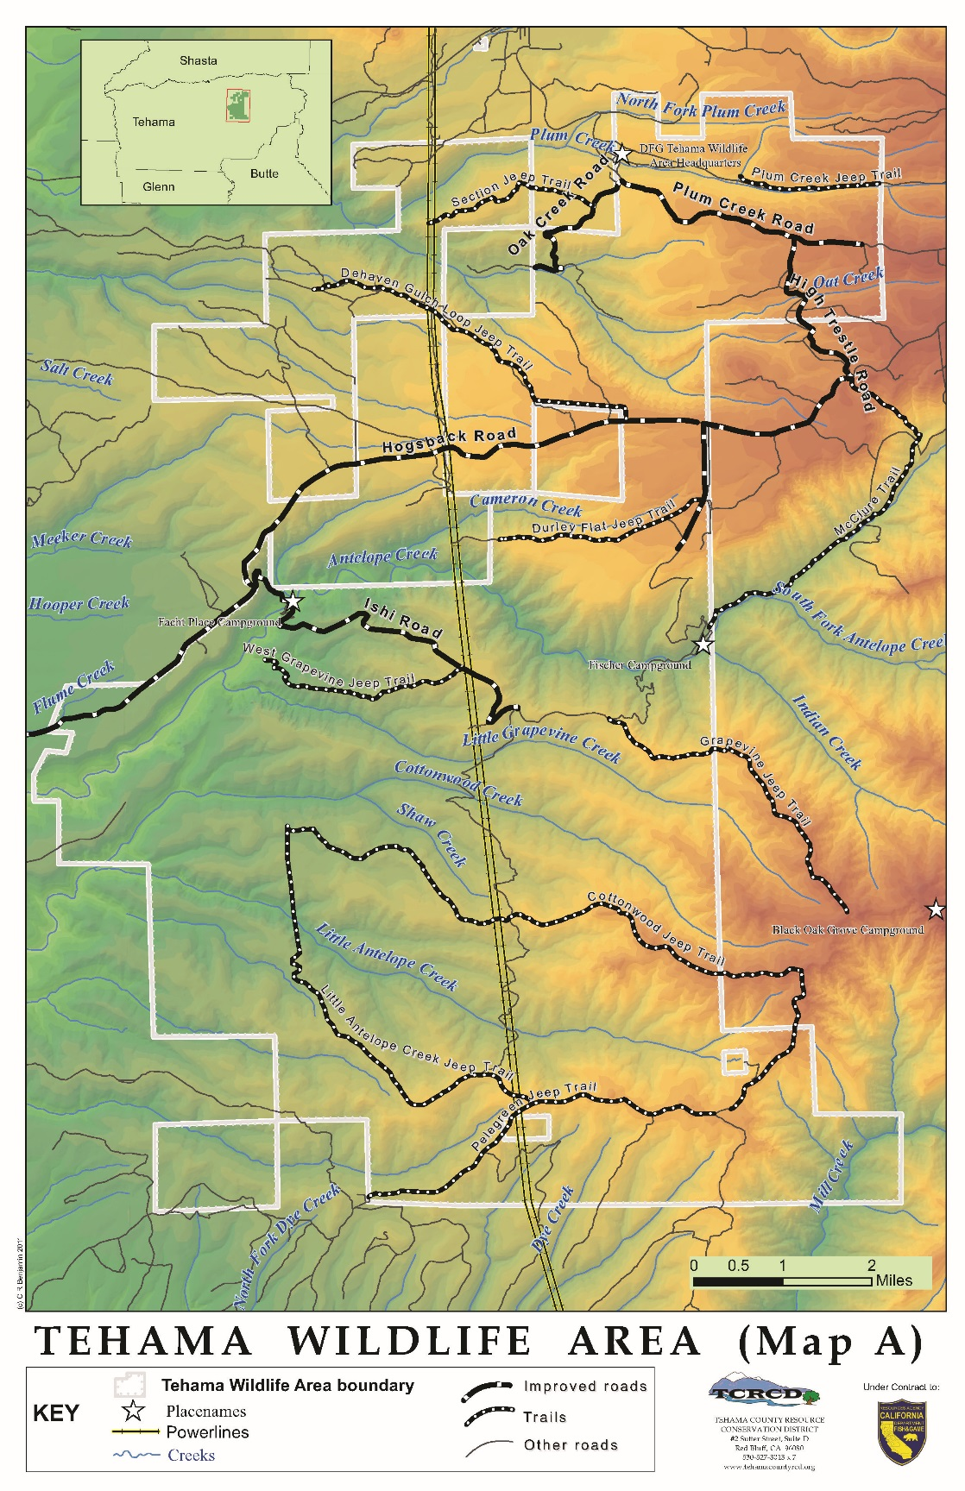

Bibliography

Agee, James K; Bahro, Berni; Finney, Mark A; Omi, Philip N; Sapsis, David B;
Skinner, Carl N; van Wagtendonk, Jan W; Weatherspoon, C. Phillip (In press.)
“The use of shaded fuelbreaks in landscape fire management.” Forest Ecology and Management.

Bean, Jack. Sierra Pacific Industries, Regional Manager, Stirling City, California.
Personal communication with author, 11/1999.

Chang, Chi-Ru. 1996. “Ecosystem responses to fire and variation in fire regimes.” Pages 1071-1100 in Sierra Nevada Ecosystem Project: Final report to Congress, vol.
II, Assessments and scientific basis for management options. Davis: University of California, Centers for Water and Wildland Resources.

Conlin, Andrew. USDA-NRCS Soil Scientist, Chico, California. Personal communication with author, 9/1998.

Fire Effects Information System [Online] (1996, September). Prescribed Fire and Fire
Effects Research Work Unit, Rocky Mountain Research Station (producer).
Available: www.fs.fed.us/database/feis/

Forbes, Judy. Fire Management Officer, USDA, U.S. Forest Service, Lassen National Forest, Susanville, California. Personal communication with author, 1/07/1999.

Francis, Jay. Collins Pine Forest Manager, Chester, California. Personal communication with author, 12/1/1999.

Furbush, P. 1953. “Control of medusa-head on California ranges.” Journal of Forestry 51: 118-121.

Green, L.R. 1977. “Fuelbreaks and other fuel modifications for wildland fire control.”
USDA Agricultural Handbook. 499.

Hastings, M.S. and J.M. DiTomaso. 1996. “Fire controls yellow starthistle in California.”Restoration & Management Notes 14(2): 124-128.
Husari, Susan and Kevin McKelvey. 1996. “Fire-Management Policies and Programs.”
Pages 1101-1118 in Sierra Nevada Ecosystem Project: Final report to Congress, vol. II, Assessments and scientific basis for management options. Davis: University of California, Centers for Water and Wildland Resources.

Klein, A., J. Crawford, J. Evens, T. Keeler-Wolf, and D. Hickson. 2007. Classification of the vegetation alliances and associations of the northern Sierra Nevada Foothills, California. Report prepared for California Department of Fish and Game. California Native Plant Society, Sacramento, CA.

Lassen National Forest, 1995. Barkley Fire Salvage Final Environmental Impact Statement, Lassen National Forest, Almanor District, Chester, California, 96020.

McKell, C.M., A.M. Wilson, and B.L. Kay. 1962. “Effective burning of rangelands infested with medusahead.” Weeds 10: 125-131.

Norman, S.P. & A.H. Taylor. 1996. “Fire History of selected sites in the Deer Creek and
Mill Creek Watersheds, Lassen National Forest, California.” Special report submitted to the Lassen National Forest for use in the Deer, Mill and Antelope Creeks Watershed Assessments.

California Department of Fish and Game, September 1994. “Policies and Procedures for Response to Fires in Wildlands.”

California Department of Fish and Game, 2011. “Initial Study/Mitigated Negative Declaration Tehama Wildlife Area Fish Passage Improvement Project.” March 2011.

State of California, Division of Mines and Geology, Geologic Map of California, Chico Sheet, 1960.

Stelle, Ed. California Department of Forestry and Fire Protection, Batallion Chief,
Tehama County Fire/CDF, Red Bluff, California. Personnel communication with author, 2/2000.

Taylor, Alan and Carl Skinner. 1998. “Fire history and landscape dynamics in a late
successional reserve, Klamath Mountains, Ca, USA.” Forest Ecology and
Management, 111 (1998) 285-301.

Tehama County Resource Conservation District. 2008. Tehama East Community Wildlife Protection Plan. Tehama County Resource Conservation District.

Tehama County Resource Conservation District. 2009. Tehama East Watershed Assessment and Management Plan. Tehama County Resource Conservation District.

United States Department of Agriculture, Soil Conservation Service, 1967. Tehama
County Soil Survey. U.S. Government Printing Office, Washington D.C. 20402

United States Department of Agriculture, Forest Service, 1995. Technical Fuels Report.
Pacific Southwest Region, Lassen, Plumas and Tahoe National Forests.

United States Department of Agriculture, Forest Service, 1998. GIS layers showing
historic fires greater than 100 acres were created by the Forest Service’s Remote Sensing Lab, Sacramento, California.

United States Department of Agriculture, Forest Service, 1999. GIS layers showing
unroaded areas on Forest Service managed land greater than 5,000 acres in size, and existing Research Natural Areas were created by the Forest Service’s Remote Sensing Lab, Sacramento, California.

Volke, Russel. Silviculturalist, USDA, U.S. Forest Service, Lassen National Forest, Chester, California. Personal communication with author, 1/13/2000.

Volke, Russel, 1999. USDA, U.S. Forest Service, Lassen National Forest, Chester, California. Unpublished report summarizing the suitability of various silvicultural options for fuels treatment projects.

Weatherspoon, Phillip, and Carl Skinner. 1995. “An assessment of factors associated
with damage to tree crowns from the 1987 wildfires in Northern California.” Forest Science, Vol. 41, No. 3, August 1995.

Weatherspoon, Phillip, and Carl Skinner. 1996. “Landscape level strategies for fuels management in Sierra Nevada Forests.” Pages 1471-1492 in Sierra Nevada Ecosystem Project: Final report to Congress, Vol. II, Assessments and scientific basis for management options. Davis: University of California, Centers for Water and Wildland Resources.

